COBOLIO.pm – The COBOL I/O utility

COBOLIO.pm is a small Perl module that will assist in viewing and manipulating COBOL data structures and parsing files based on COBOL file data definitions (usually COPYLIB members). This utility's options include:
- Download a mainframe file and display it's contents on your screen in a formatted manner (including packed decimal fields). The display will identify the starting & ending position numbers for the various fields.
- Displaying a file layout / definition including field starting and ending positions
- Parse any data you read into CSV format to import to a database or spreadsheet.
- Search for data values in a file and (optionally) change the data and write the data back out.

To use this module, you need to have a Perl interpreter installed (www.activestate.com) or cqPerl, which is installed as part of any of the Rational Suites products. The module, COBOLIO.pm should be installed in the Perl “lib” directory. For Activestate, this is normally “c:\perl\site\lib”. For cqPerl, the directory will be “c:\Program Files\Rational\ClearQuest\lib”.

You also need to download the source code file(s) you want to work with, at least the COBOL source code or COPYLIB member. If you want to work with a data file, you also need to download the data file.

The new TK GUI interface (COBGUI.pl) provides a point-and-click GUI that will perform most of these functions for you. To automatically download mainframe files from the mainframe, you will need the script file “getafile.pl”, and you must have a user ID with UNIX or FTP access. Check with your security admin to request permission to FTP files.

Using COBGUI
Run the COBGUI.pl script by typing

CQPerl COBGUI.pl

on the command line. You can also simply double-click the file from an Explorer window, if you have Windows configured to run cqperl for “.pl” files. When you start the script, it will display the following screen:
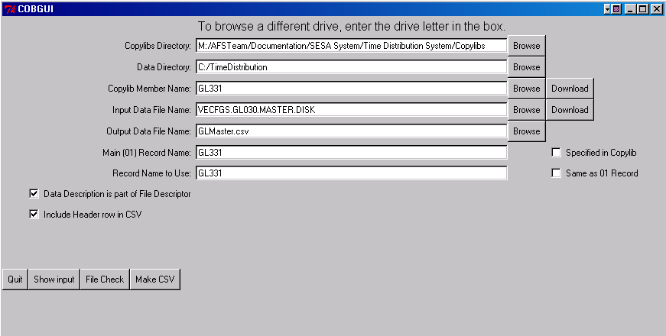

This allows you to specify all the directory and file names that you want to work with. These values are “sticky”, so once they are entered the program will save them for the next time you run COBGUI.

The buttons at the bottom of the screen perform the significant actions. “Show input” will display the information in the Copylib member, specified in the “Copylib Member Name” box (it must be in the directory specified in the “Copylibs Directory” box).

The “File Check” button will check all the file names and directories specified, to make sure the program can find anything. If any files are missing, a warning is displayed and the names turn red.

The “Make CSV” button will create a CSV (comma-separated values) file, in MS Excel format, using the Copylib and Data file that you have specified. The CSV will be placed in the directory specified in the “Data Directory” box.

You can download any mainframe files you need using the “Download” buttons next to the appropriate files. You will be prompted for a TSO user ID and password. Your TSO user ID must have the appropriate permissions to use FTP on the mainframe. Copylibs that you download will be copied to the directory specified under “Copylibs Directory”, and data files will be copied to the directory in the “Data Directory” box.

Note: The modules that create these GUI screens have a minor issue refreshing the screen (actually a shortcoming of the Win32 functions used). Move the mouse pointer over the window to force it to refresh properly.

Creating a custom script

You can create your own script to use the function of the COBOLIO.pm module. Below are the functions available, and an example of a client script that uses the module.

The public functions and a brief description follow:

- new - creates a new COBOL record format (required for all COBOLIO executions). You must supply:
  - copyLibFileName - file name of the copylib / data definition member that describes the respective file to be analyzed. This member can only include the file description / data definition(s) relative to the file to analyzed. No other program code can be included in this member.
  - fileDescriptorName (FD name) - You must supply a unique file descriptor name, even if the item is not used within the file descriptor. You can have several file descriptors for a COBOL copylib member, like you would in a COBOL program to do INPUT -> Process -> OUTPUT.
  - fileDescriptorFlag - This must be a "1" if the item is used within a file descriptor, "0" if not. This is necessary so the module knows whether to use a "implicit" REDEFINES on multiple "01" record level names, like COBOL does. In other words, a value of "1" treats "01" leval data names as a redefines of the previous "01" level encountered; a value of "0" will result in the data under the second "01" level entry being considered to physically follow that of the first "01" level entry (to accommodate the situation wherein two or more "01" level entries in working storage are concatenated under a single "01" level entry under an FD).
  - first01RecordName - If the copylib file does not contain an "01" record level name on the first line, you can supply one to use here.
- PrintLayouts - Prints out the names, levels, start positions, lengths, etc. of the data members to STDOUT (your monitor). Requires the fileDescriptorName as a parameter.
- ReadRecInto - Accepts a single line of data and parses it into the fileDescriptor record that you specify.
- GetVal - Returns the value of a defined data member (field) or record, numerically formatted (if numeric). Requires the name of the item, the fileDescriptorName, and optionally a record name as a qualifier.
- SetVal - Assigns a data value to a defined data member (field) or record. Requires the name of the item, the new value, the fileDescriptorName, and optionally a record name as a qualifier.
- GetCSVHeader - Returns the data names of the data items in CSV format (assumes the first record in the file contains the respective data field column headings). Requires the fileDescriptorName, and optionally a record name to start with.
- GetCSVRecord - Returns the current values of a data record in CSV format. Requires the fileDescriptorName, and optionally a record name to start with.

Multiple of the options described above can be processed in a single execution of COBOLIO.

Examples:
This example uses a COPYLIB member named TD333.cob (stored on drive M:) to parse a data file named TD030.RPTINFO.DISK (which is found in the default directory). It then creates an Excel CSV file, with data name headers, and parsed data.

#!/bin/cqperl
#
# make_csv.pl - 12/2/2002 - HHolt
#
# Creates a file of CSV records from given data file and copylib member
#
#
# Set the variables for running
#
##########################################################################################
###
# Change these variables for the stuff you are working with
###
# copylibname - the file name of the copylib member
# fdname - the "File Descriptor" name that you want to use
# FDflag - Set to 1 to use implicit "01" record redefines
# (supply 01 record name)
# 0 to ignore (treat as working storage)
# record01 - Name of the first "01" record (optional)
# recName - Name of the record to use for the output file
# (often the same as record01)
# datafile - Name of the data file to read in
# outfile - Output file name (should include ".csv")
#
$copylibname = "M:/copylibs/TD333.cob";
$fdname = "TD030_FILE";
$FDflag = 1;
$record01 = "TD333";
$recName = "TD333";
#
$datafile = "TD030.RPTINFO.DISK";
$outfile = "TD030RptInfo.csv";
#
###
##########################################################################################
#
use COBOLIO;
#
# Initialize some tracking variables
#
#
###########
open(DATAFILEHANDLE, $datafile);
###########
#
$cobio = COBOLIO->new($copylibname, $fdname, $FDflag, $record01);
#

open(OUTPUTFILEHANDLE, ">$outfile");
$tmp = <DATAFILEHANDLE>;

$headerLine = $cobio->GetCSVHeader($fdname, $recName);
print OUTPUTFILEHANDLE "$headerLine\n";

$cobio->PrintLayouts();

$empnum = $cobio->GetVal("employee-number");

while(<DATAFILEHANDLE>) {
$cobio->ReadRecInto($_, $fdname);
$recordLine = $cobio->GetCSVRecord($fdname, $recName);
print OUTPUTFILEHANDLE "$recordLine\n";
}

close(OUTPUTFILEHANDLE);
close(DATAFILEHANDLE);

